PART 1: Connecting & Shaping the Data (25 points)

Open a new Power BI Desktop file, and complete the following steps:
1) Update your Power BI options and settings as follows: (2 points)
- Deselect the "Autodetect new relationships after data is loaded" option in the Data Load tab
- Make sure that Locale for import is set to "English (United States)" in the Regional Settings tab
2) Connect to the Customers csv file (4 points)
- Make sure that headers have been promoted and confirm that data types are accurate (Note: "customer id" should be whole numbers, and both "customer acct num" and "customer postal code" should be text)
- Add a new column named "full name" to merge the the "first name" and "last name" columns, separated by a space
- Create a new column named "birth year" to extract the year from the "birthdate" column, and format as whole numbers
- Create a conditional column named "has children" which equals "N" if "total children" = 0, otherwise "Y"
3) Connect to the Products csv file (3 points)
- Make sure that headers have been promoted and confirm that data types are accurate (Note: "product id" should be whole numbers, "product sku" should be text), "product retail price" and "product cost" should be decimal numbers)
- Add a calculated column named "discount price", equal to 90% of the original retail price
  - Format as a fixed decimal number, and then use the rounding tool to round to 2 digits
- Replace "null" values with zeros in both the "recyclable" and "low fat" columns
4) Connect to the Stores csv file (3 points)
- Make sure that headers have been promoted and confirm that data types are accurate (Note: "store id" and "region id" should be whole numbers)
- Add a calculated column named "full address", by merging "store city", "store state", and "store country", separated by a comma and space (hint: use a custom separator)
- Add a calculated column named "area code", by extracting the characters before the first dash ("-") in the "store phone" field
5) Connect to the Regions csv file (1 points)
- Make sure that headers have been promoted and confirm that data types are accurate (Note: "region id" should be whole numbers)

6) Connect to the Calendar csv file (6 points)
- Make sure that headers have been promoted and use the date tools in the query editor to add the following columns:
  - Start of Week (starting Monday)
  - Name of Day
  - Start of Month
  - Name of Month
  - Quarter of Year
  - Year
7) Connect to the Returns csv file (1 points)
- Make sure that headers have been promoted
- Confirm that data types are accurate (all ID columns and quantity should be whole numbers)
8) Connect to the "Transactions" folder containing both the Transactions_1997 and Transactions_1998 csv files (3 points)
- Click the "Content" column header (double arrow icon) to combine the files, then remove the "Source.Name" column
- Confirm that headers have been promoted
- Confirm that data types are accurate (all ID columns and quantity should be whole numbers)
  - Spot check: You should see data from 1/1/1997 through 12/30/1998 in the "transaction_date" column
9) Disable "Include in Report Refresh" for above created 7 queries, then Close & Apply (2 points)
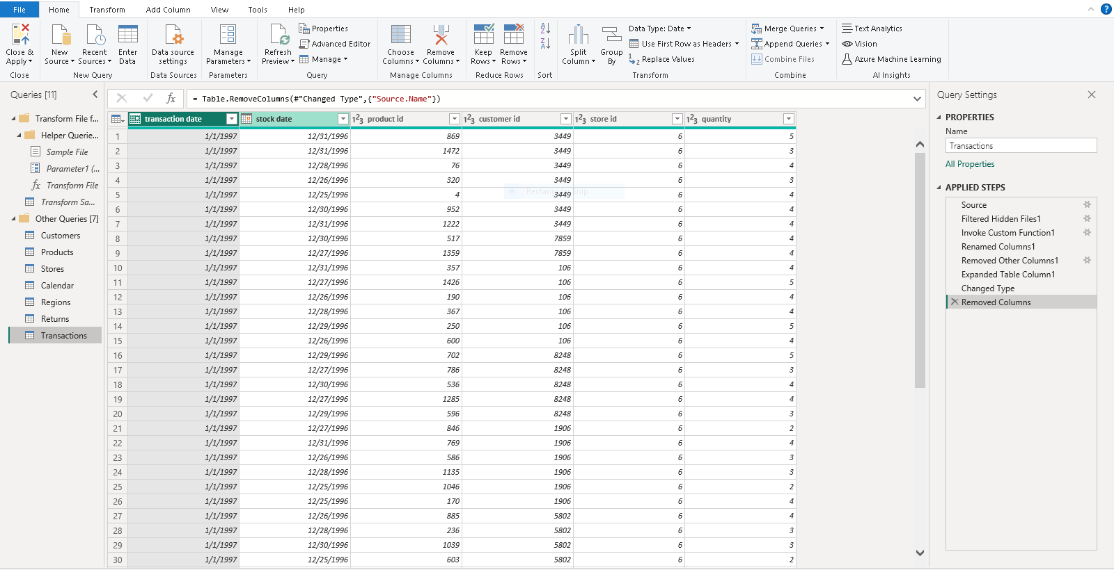
- Confirm that all 7 tables are now accessible within both the Table view and the Model view

PART 2: Creating the Data Model (10 points)
1) In the Model view, arrange your tables with the lookup tables above the data tables (3 points)
- Connect Transaction to Customers, Products, and Stores using valid primary/foreign keys
- Connect Transaction to Calendar using transaction_date and date fields. Create also inactive relationship using "stock_date" and date fields
- Connect Returns to Products, Calendar, and Stores using valid primary/foreign keys
- Connect Stores to Regions as a "snowflake" schema
2) Confirm the following (2 points):
- All relationships follow one-to-many cardinality, with primary keys (1) on the lookup side and foreign keys (*) on the data side
- Filters are all one-way (no two-way filters)
- Filter context flows "downstream" from lookup tables to data tables
- Data tables are connected via shared lookup tables (not directly to each other)
3) In the Table view, complete the following (5 points):
- Update all date fields (across all tables) to the "m/d/yyyy" format using the formatting tools in the Modeling tab
- Update "product retail price", "product cost", and "discount price" to Currency ($ English) format
- In the Customers table, categorize "customer city" as City, "customer postal code" as Postal Code, and "customer country" as Country/Region
- In the Stores table, categorize "store city" as City, "store state" as State or Province, "store country" as Country/Region, and "full address" as Address
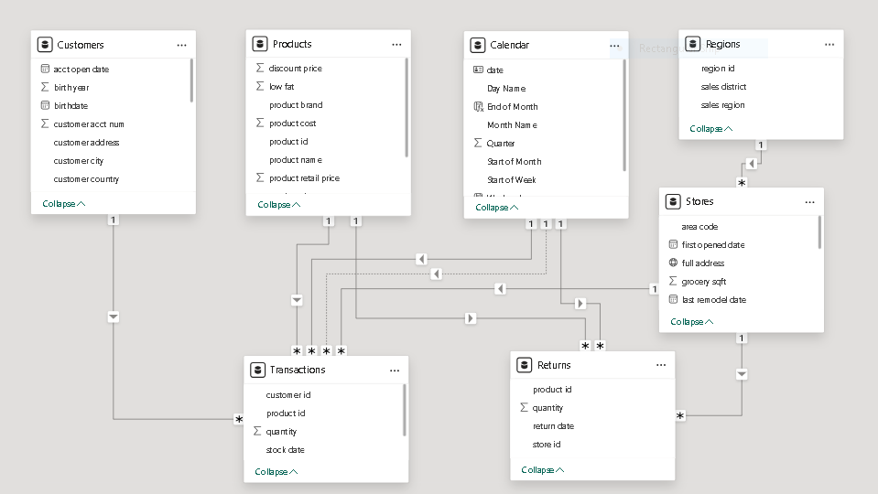
- Mark Calendar table as date table

PART 3: Adding DAX Measures (30 points)
1) In the Table view, add the following calculated columns (10 points):
- In the Calendar table, add a column named "Weekend"
  - Equals "Y" for Saturdays or Sundays (otherwise "N")
- In the Calendar table, add a column named "End of Month"
  - Returns the last date of the current month for each row
- In the Customers table, add a column named "Short Country"
  - Returns the first three characters of the customer country, and converts to all uppercase
- In the Stores table, add a column named "Years Since Remodel"
  - Calculates the number of years between the current date (TODAY()) and the last remodel date
2) Create a new Blank table named “All Measures” and add the following measures (20 points):
- Create new measures named "Quantity Sold" and "Quantity Returned" to calculate the sum of quantity from each data table
- Create new measures named "Total Transactions" and "Total Returns" to calculate the count of rows from each data table
- Create a new measure named "Return Rate" to calculate the ratio of quantity returned to quantity sold (format as %)
- Create a new measure to calculate "Total Revenue" based on transaction quantity and product retail price, and format as $ (hint: you'll need an iterator)
- Create a new measure to calculate "Total Cost" based on transaction quantity and product cost, and format as $ (hint: you'll need an iterator)
- Create a new measure named "Total Profit" to calculate total revenue minus total cost, and format as $
- Create a new measure to calculate "Profit Margin" by dividing total profit by total revenue (format as %)
- Create new measures named "Last Month Transactions", "Last Month Revenue", "Last Month Profit" and "Last Month Returns" to calculate total transactions, total revenue, total profit and total returns for last month
- Create a new measure named "Revenue Target" based on a 5% lift over the previous month revenue, and format as $

PART 4: Building the Report (35 points)
1) Insert Text tox and type “Sales Analysis” as a title (Font Size:20, Font Color: Blue, Bold) (2 points)
2) Insert a Matrix visual to show Total Transactions, Total Profit, Profit Margin, and Return Rate (on values) by product brand (on rows) (6 points)
- Add conditional formatting to show data bars on the Total Transactions column, and color scales on Profit Margin (White to Green) and Return Rate (White to Red)
- Add a visual level Top N filter to only show the top 30 product brands by Total Transactions, then sort descending by Total Transactions
3) Add a KPI Card to show Total Transactions, with Start of Month as the trend axis and Last Month Transactions as the target goal (7 points)
- Update the title to "Current Month Transactions", and format as you see fit
- Create two more copies: one for Total Profit (vs. Last month Profit) and one for Total Returns (vs. Last Month Returns)
- Make sure to update titles, and change the Returns chart to color coding to "Low is Good"
4) Add a Map visual to show Total Transactions by store city (2 points)
5) Add a Slicer for store country (3 points)
- Under the " Slicer settings " in the Selection pane, activate the "Show Select All" option
Pro Tip: Change the style in the "Options" formatting menu to Tile and resize to create a vertical stack (rather than a list)
6) Next to the map, add a Treemap visual to break down Total Transactions by store country (3 points)
- Pull in store state and store city beneath store country in the "Category" field to enable drill-up and drill-down functionality
7) Beneath the map, add a Column Chart to show Total Revenue by week, and format as you see fit (4 points)
- Add a visual level filter to only show data for 1998
- Update the title to "Weekly Revenue Trending"
8) In the lower right, add a Gauge Chart to show Total Revenue against Revenue Target (6 points)
- Add a visual level Top 1 filter to show the latest Start of Month
- Remove data labels, and update the title to "Revenue vs. Target"
9) Select the Matrix and activate the Edit interactions option to prevent the Treemap from filtering (2 points)
Save the report in *.pbix format (name it Sales Analysis).

